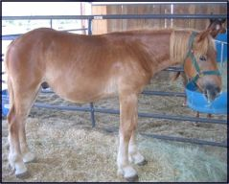
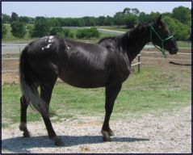
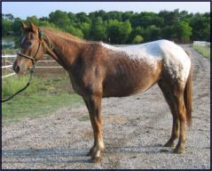
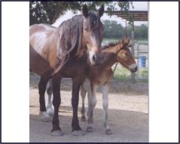
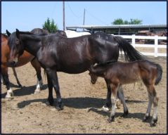
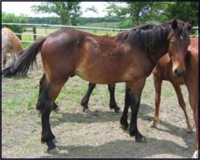
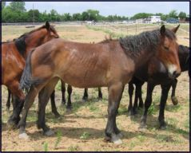
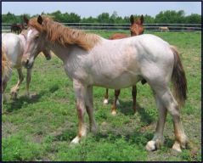
Horses In Need!
Hope for Horses Equine Rescue, Inc.
www.hopeforhorses.com
Hope for Horses Equine Rescue
www.hopeforhorses.com
972-734-6218
Hope for Horses Equine Rescue
www.hopeforhorses.com
972-734-6218
Hope for Horses Equine Rescue
www.hopeforhorses.com
972-734-6218
Hope for Horses Equine Rescue
www.hopeforhorses.com
972-734-6218
Hope for Horses Equine Rescue
www.hopeforhorses.com
972-734-6218
Hope for Horses Equine Rescue
www.hopeforhorses.com
972-734-6218
Hope for Horses Equine Rescue
www.hopeforhorses.com
972-734-6218
Hope for Horses Equine Rescue
www.hopeforhorses.com
972-734-6218
Hope for Horses Equine Rescue
www.hopeforhorses.com
972-734-6218
Hope for Horses Equine Rescue
www.hopeforhorses.com
972-734-6218
PMU and Premarin stand for PREgnant MARes URINe. Premarin, once the top selling drug, is a hormone replacement therapy drug given to menopausal and osteoporosis patients. Due to modern research that finds Premarin causes cancer in humans, the demand for it is going down. Meanwhile, the farms that just closed down have thousands of horses they desperately want to get rid of. Many will end up in the slaughter house if we don’t save them. The cost to rescue them includes a basic price to purchase (at meat price), vaccinations (VEWT, Rabies, Flu/Rhino, and West Nile), border fees, and transport (from Canada). These horses have had limited handling. The mares are kind and patient as they have stood tied for long periods of time with people working behind them, yet they have not been shown much love.
These pictures are just some of the many horses available. Please see our website for pictures of other available horses. The types of horses in need are Quarter Horses, Draft Horses, and crosses. We have pregnant mares, open mares, foals, stallions, and geldings. Please contact us for information on any of the horses.
These horses are in Texas waiting to find new homes. Please consider adopting one of them. We would greatly appreciate donations to help with the care and feeding of these horses at our rescue. Please send your tax deductible donations to
Hope for Horses Equine Rescue, 9381 County Rd 470, Blue Ridge, TX 75424
PMU HORSES IN NEED!

